**救砖/线刷流程**

1. **驱动安装**

驱动及烧录工具下载地址：

https://github.com/CrealityOfficial/Ender-3_V3_KE_Annex

1. 拔出屏幕与打印机连接线，用十字螺丝刀拆开屏幕外壳

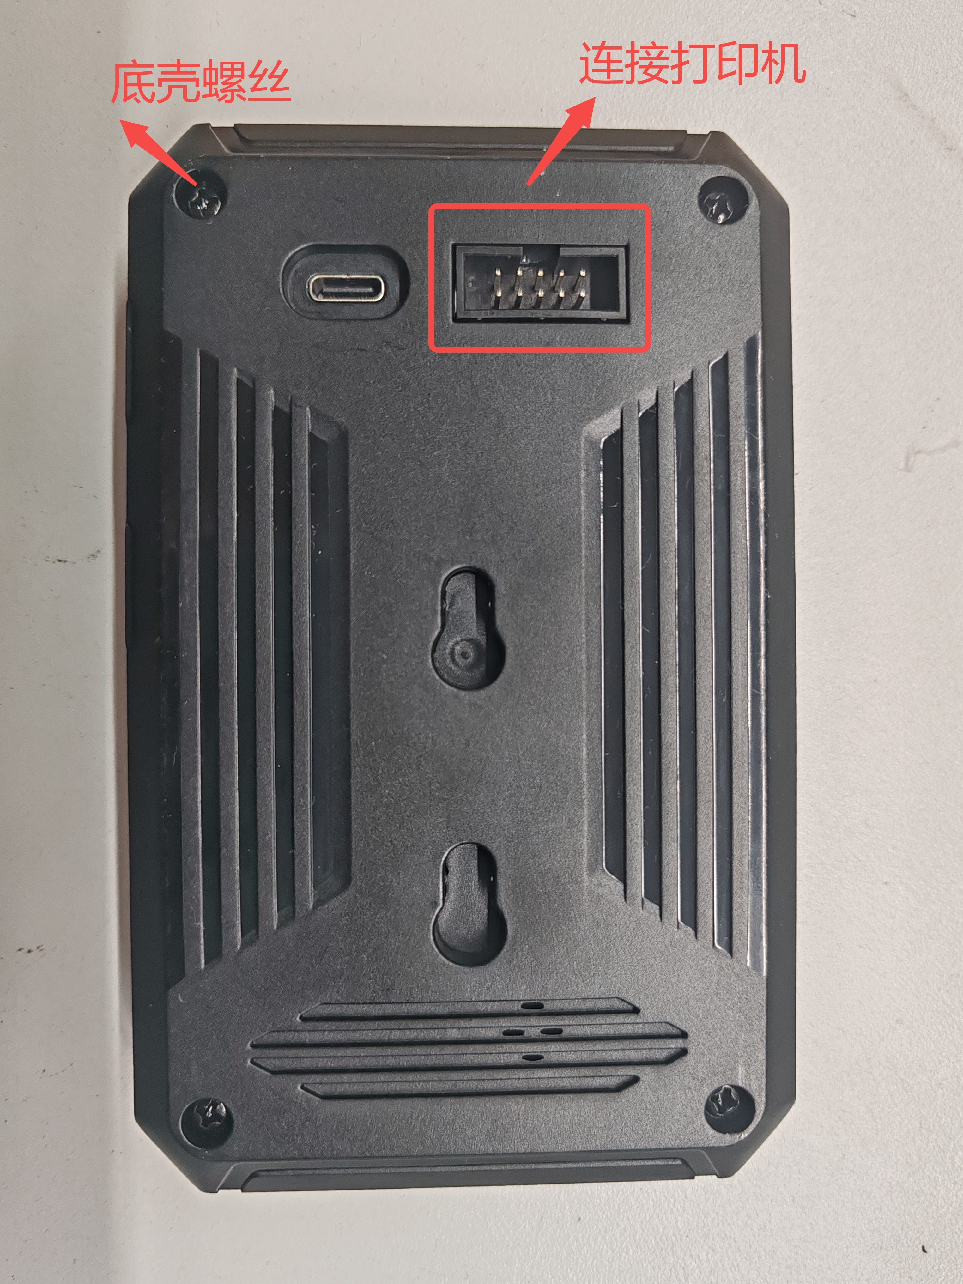

1. 用MircoUSB线(如图所示)连接电脑和主板MircoUSB接口，同时按下主板端的“boot按钮”和“复位按钮” (如图示），然后保持3S钟后，先松开“复位按钮”按钮再松开“boot按钮”按钮， 此时系统处于待刷写状态。

|  |  |
| --- | --- |
|  |  |

1. 查看设备管理器【桌面 ->此电脑(右键,管理) ->设备管理器)】，找到“Ingenic USB BOOT DEVICE” 提示标记(图标有感叹号，需要装驱动）

备注：

MircoUSB线有两种规格：一种是只能供电使用的；还有一种是通讯供电两用的信号线。如果按照2步骤操作，设备管理器没有弹出带黄色感叹号的驱动信息，那可能是使用的MircoUSB线属于第一种类型线，只能充电使用的。这种情况下需要更换成第二种信号线，然后重新按照2、3步骤操作一遍。

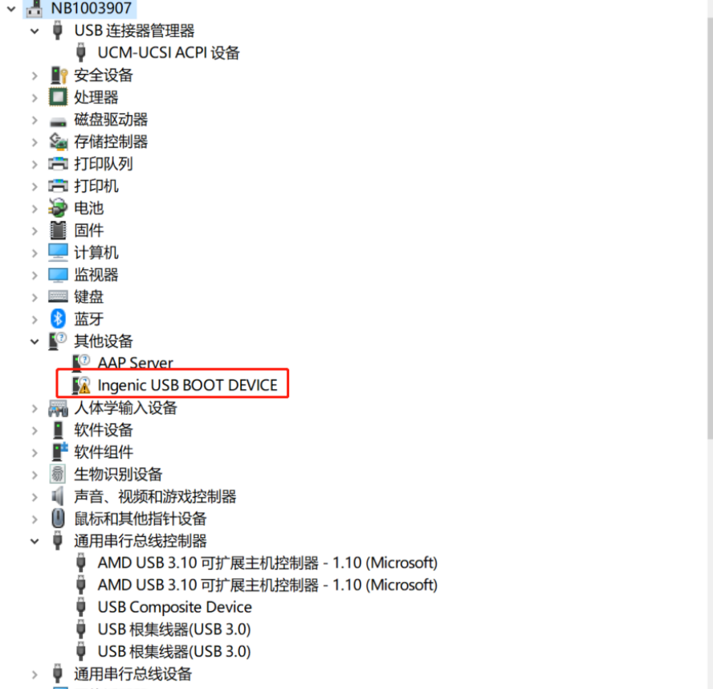

1. 选中“Ingenic USB BOOT DEVICE” -> 右键，选择更改驱动程序 ->再选择 “浏览我的电脑以查询驱动程序” -> 然后找到软件包里的“cloner-win32-driver”文件，点击下一步，系统自动安装驱动。

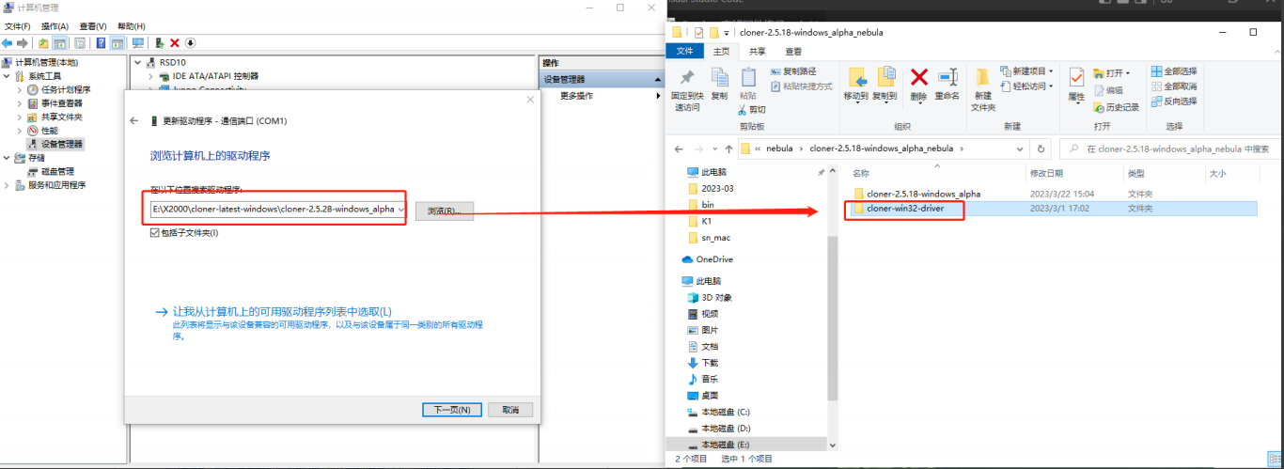

2. **烧录工具使用**

1. 驱动安装完成后，双击打开软件包里的烧录工具(如图所示）。

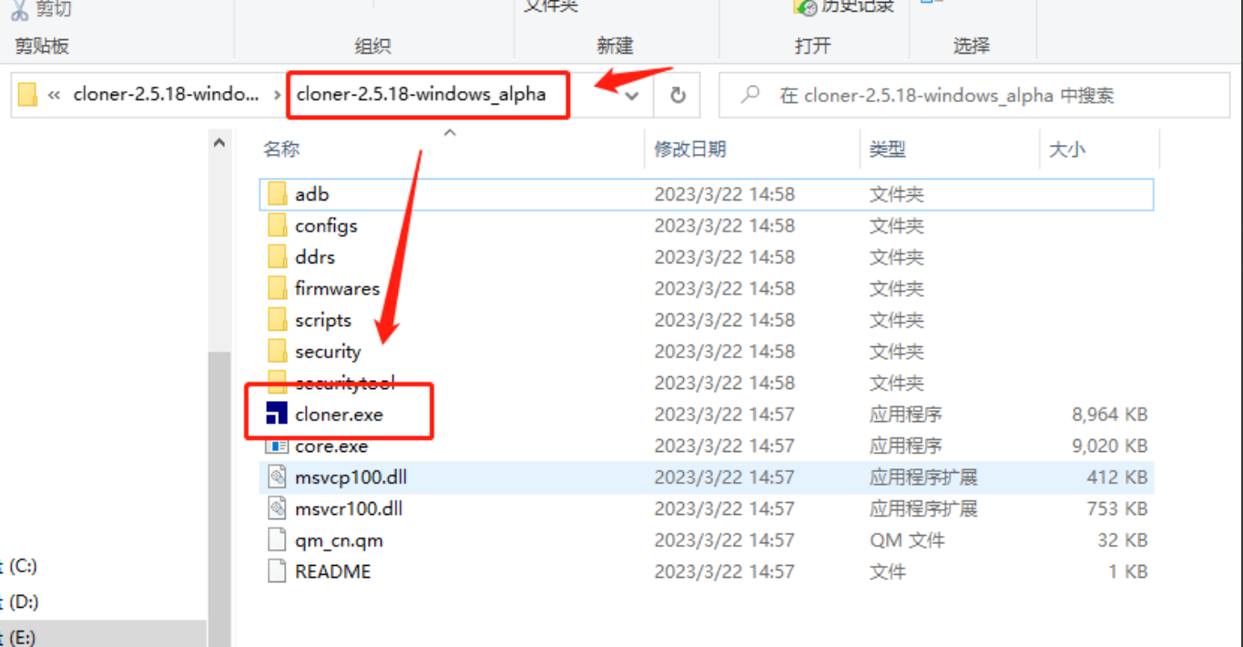

PS:如遇到如图错误，请勾选以管理员身份

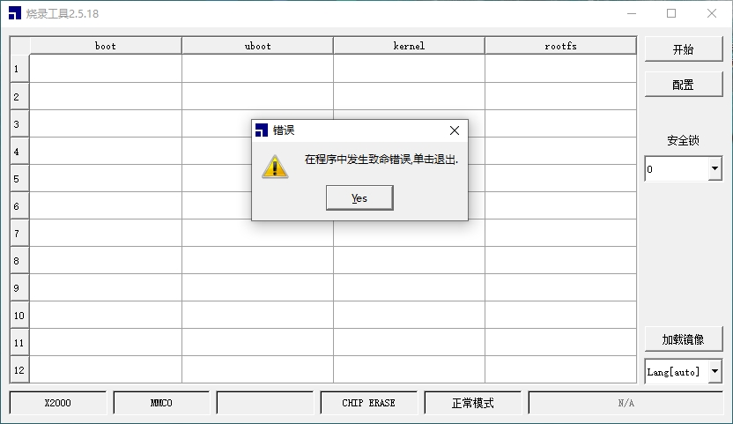

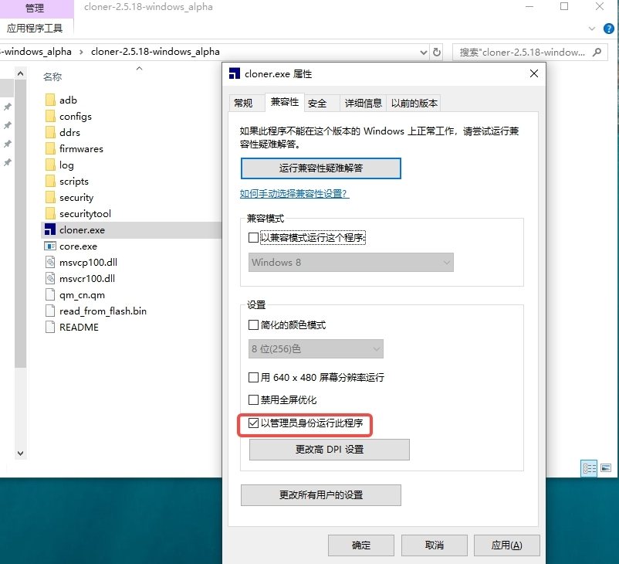

1. 点击“加载镜像”按钮，选择所需版本的镜像包里的文件(注意是.ingenic的扩展名文件)然后点击“打开”。

线刷包下载链接： https://github.com/CrealityOfficial/Ender-3_V3_KE_Klipper

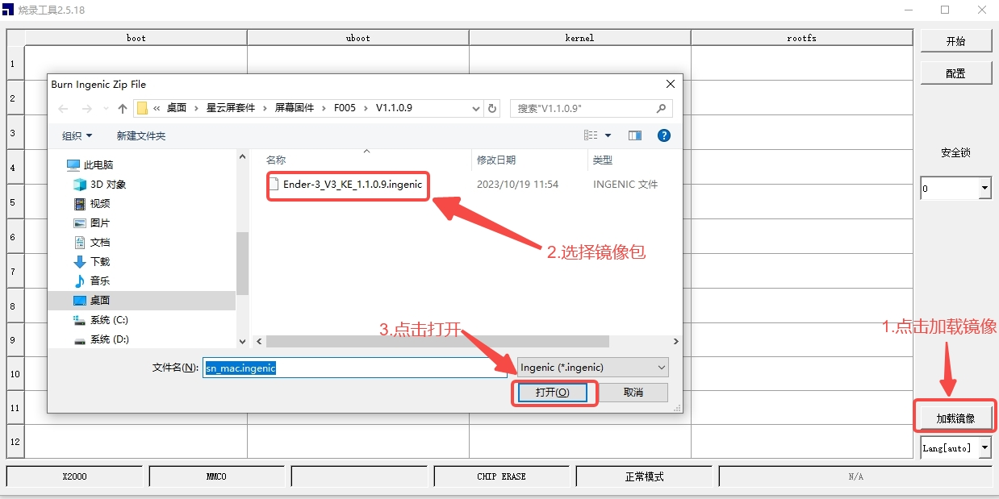

1. 选择点击“开始”按钮。然后在主板上同时按下“复位按钮”按钮和“boot按钮” 按钮，同上面的步骤一样，先松开“复位按钮” ，再松开“boot按钮”。

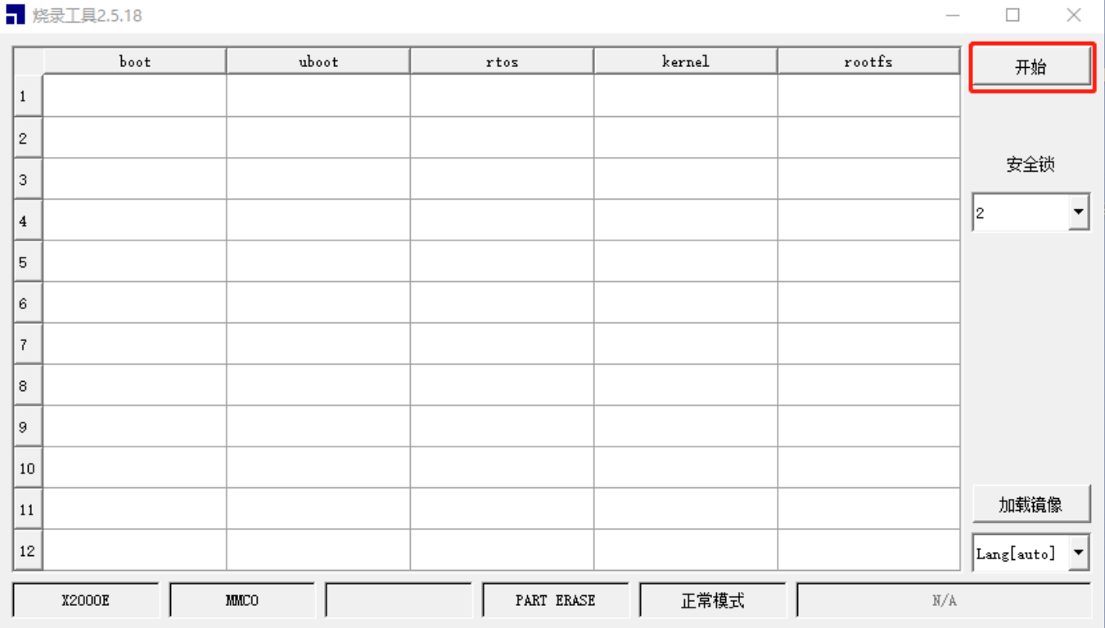

1. 此时程序开始自动烧录，可能通过进度条查看最新的烧录进度。

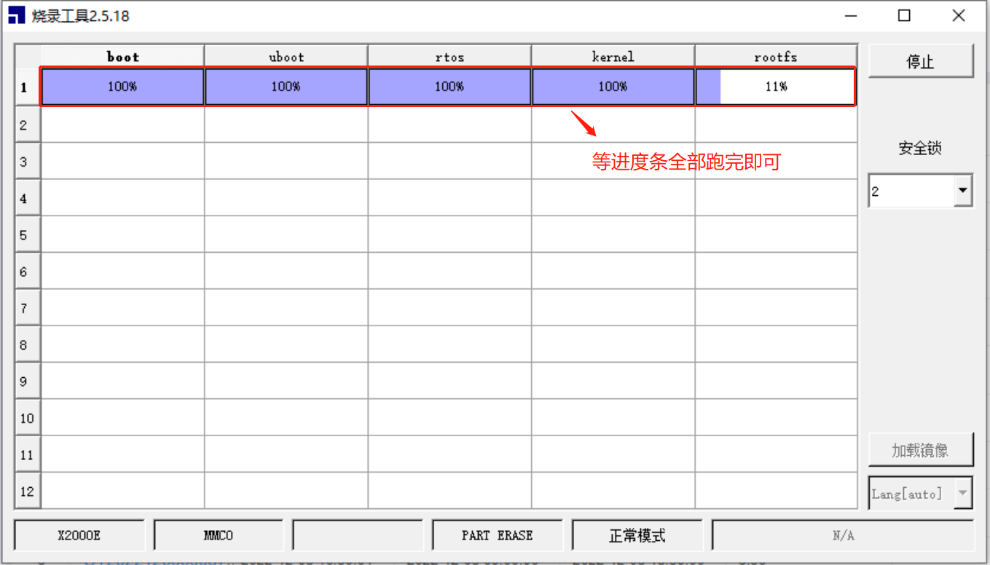

1. 进度完成100%，烧录成功。

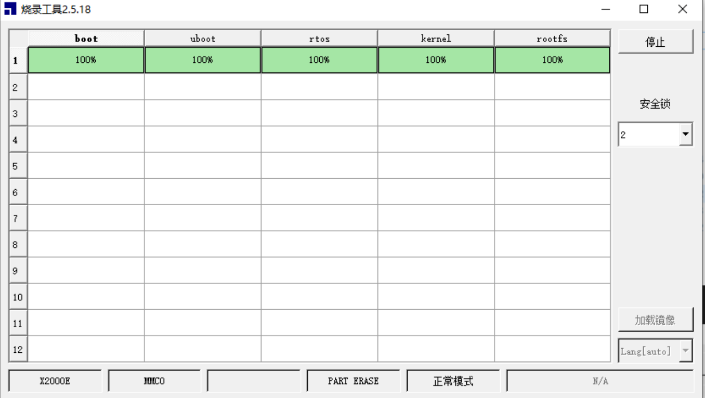

3. **重新安装好屏幕外壳，连接屏幕与打印机，再接通打印机电源**

**翻译：**

**Brick Rescue/Wire Brushing Process**

1. **Driver Installation**

Driver and Burning Tool Download Link:

https://github.com/CrealityOfficial/Ender-3_V3_KE_Annex

**1.1 Unplug the screen and printer connection cable, and use a Phillips screwdriver to disassemble the screen casing.**



**1.2 Connect the computer and the mainboard's MircoUSB port using a MircoUSB cable (as shown in the picture), press the "boot button" and the "reset button" on the mainboard at the same time (as shown in the picture), hold for 3 seconds, then first release the "reset button" and then release the "boot button". At this point, the system is in a state ready for flashing.**

|  |  |
| --- | --- |
|  |  |

**1.3 Check the Device Manager [Desktop -> This PC (Right click, manage) -> Device Manager], find the "Ingenic USB BOOT DEVICE" warning sign (icon with an exclamation mark, need to install driver ).**

Note:

There are two types of MicroUSB cables: one is for power supply only; the other is a dual-purpose signal cable for communication and power supply. If the device manager does not pop up with the driver information with a yellow exclamation mark after following Step 2, it may be that the MicroUSB cable used belongs to the first type, which can only be used for charging. In this case, you need to replace it with the second type of signal cable, and then repeat Steps 2 and 3.



**1.4 Select "Ingenic USB BOOT DEVICE" -> Right click, choose "Update Driver" -> Then select "Browse my computer for driver software" -> Locate the "cloner-win32-driver" file in the software package, click Next, and the system will automatically install the driver.**



2. **Use of Flashing firmware Tool**

**2.1 After the driver installation is complete, double-click to open the flashing tool in the software package (as shown in the figure).**



PS: If you encounter errors as shown, please check as an administrator.





**2.2 Click the "Load Image" button, select the file in the image package of the required version (note it is a .ingenic extension file). Then click "Open".**

Wire Brush Pack Download Link: https://github.com/CrealityOfficial/Ender-3_V3_KE_Klipper



**2.3 Select and click the "Start" button. Then, simultaneously press the "Reset Button" and "Boot Button" on the motherboard. Following the same steps as above, release the "Reset Button" first, then release the "Boot Button".**



**2.4 At this point, The program starts to automatically flash the firmware, which can be monitored through a progress bar for the latest flashing progress.**



**2.5 Progress completed 100%, successful burn-in.**



3. **Reinstall the screen casing, connect the screen to the printer, and power on the printer again**